EXECUTIVE SUMMARY
Songsak–Mendipathar Road (SMR) ko strengthening aro improvement ka·se, weak CD works aro bridges rang·san reconstruction ka·se, Meghalaya Logistics and Connectivity Improvement Project (MLCIP) corridor do·a, World Bank fund ka·se.
Meghalaya Logistics and Connectivity Improvement Project (MLCIP)

Submitted
to

Meghalaya Infrastructure Development Finance Corporation (MIDFC) Ltd.
House No. L/A-56, Lower Nongrim Hills,Top Floor,
Meghalaya Basin Development Authority (MBDA) Building,
Shillong East Khasi Hills, Meghalaya-793003

ESIA Somaning (Summary)
Project Rang·chanchapa (Project Introduction)
Meghalaya Logistics and Connectivity Improvement Project (MLCIP) an·chingni miksongrangko dakchakanina kam ka·a, chong·motgipa nangchongmot ong·a:
a) chin·apgipa road corridor-rangni jakkalna dal·gipa bikrang aro growth center-rangona connection-ko namatna; b) grong-level aro district-level logistics infrastructure aro seva-rangko namatna;
c) select agriculture aro horticulture product-rangna marketona reach ong·e jakkalna, cost aro samai-ko komiatna; aro d) East Meghalaya-o climate-resilient transport aro logistics-ko chusok ong·e chalna institution-rangni capacity-ko bilangna.
Proposed roadko Meghalaya State bon∙kamani jakkala ong∙aha aro ROW ching∙a existing Drain jakkale ong∙a. Proposed SMR project road a∙selgipa 36 km nokgipa, Songsak Village (chainage 00+000) ato man∙gen aro Mendipathar (chainage 36+000) jakkale aganchakaha, a∙selsalo project road miksongan ong∙a.
Niyam aro kanun-rang baksa meligrik ong·ani bynta
ESIA-ara ia niyam aro kanun-rang baksa meligrik ong·a:
- World Bank Environmental aro Social Framework (ESF)
- Environmental aro Social Standards (ESS 1–10)
- India Government aro Meghalaya Government-rang environmental niyam
- Labour, forest, biodiversity aro pollution control-rang kanun

Project-rang kam-chalna samai-suchi
Nang·ni set criteria aro conditions-rang baksa, MPWD civil works contract-ko eligible contractor-na debak ong·a. Contractor-na quality materials-ko pora jakkalna, nearest authorized source aro approved manufacturer-na laga debak ong·a. Construction process-rangni somai, prescribed standard-rang meet gipa equipment-ara use debak ong·a. Contractor-na construction schedule-rang baksa required manpower-ko mobilize debak ong·a. 36 km project road-rang construction period 24 month-rang baksa plan gipa ong·a.

Chong·ni pora environment-rang sthiti
Road corridor-rang soil sandy loam ong·a, well-drained aro moderately acidic ong·a, arangni region-rang high rainfall conditions-ina typical ong·a.
Water quality mostly fresh aro unpolluted ong·a, neutral pH-rang, sufficient dissolved oxygen-rang, low turbidity (monsoon-rang chadengsa except), aro low BOD/COD values ong·a. Industrial discharge nai, aro large-scale agricultural runoff-na water body-rang affect nai ong·a. Overall, water quality domestic use-ko baksa suitable ong·a, basic treatment-na pora use debak ong·a.
Ambient noise environment mostly quiet to moderately noisy ong·a, rural area-rang characteristics-ina baksa. Baseline noise level-rang CPCB limit-rang residential aro rural area-rang somai, day aro night, most location-ona meligrik ong·a.
Project corridor-rang air quality good to moderate ong·a, rural Meghalaya-rang characteristic-ina, industrial activity kom ong·a. Ambient concentration PM₁₀, PM₂.₅, SO₂, NO₂, aro CO generally National Ambient Air Quality Standards (NAAQS)-na meligrik ong·a.
Environment aro community-rang upor project-rang potential effect
Proposed road koridoro Environment Screeningo sensitive receptors aro community assets alignmento pora dongani dakaha. Religious aro cultural site church, aro educational institution (5+400, 9+400, 9+500, 12+300) jemangan pora dakaha.

Adverse impact-rang komiatna aro project implementation smooth ong·a baksa, appropriate mitigation measures propose gipa ong·a. Ni observation aro recommendation-rang summary table-ona dekha gipa ong·a.

Table: Observation-rang aro Corresponding Recommendation-rang
Chainage | EIS Observation (Dakaha) | Proposed / Mitigation Measure Adopted (Proposal / Katchani Kam)
0+350 to 3+700 | Songsek Reserve Forest dakaha. | Forest Area (Pilak Boko) (Existing Road Blacktop ching∙a dongja, aganchakgija improvement).
2+200 | Sharp curve dakaha. | Curve improvement, pavement damage ia section-o.
3+700 | Bridge dakaha. | Bridge-ni condition fair ong∙a.
4+000 | Erosion dakaha. | Slope stabilize ka∙na aro runoff man∙enggnichi protection wall nangrimani ong∙a.
4+020 | LHS-o eroding riverbank dakaha. | Eroding riverbank protection work namnika (LHS).
4+300 | Riverbank (LHS)-o erosion dakaha. | Riverbank (LHS)-o protection work namnika.
5+300 | School Zone dakaha. | School Zone: Safety improve ka∙na speed reduction measures (20 km/hr) namnika.
5+350 | Flooding risk dakaha. | School (LHS) jakkalo jrimanganiko man∙enggnichi.
5+600 | Drainage requirement dakaha. | Box culvert nangrimani ong∙a.
8+000 | LHS-o community reserve pond dakaha; road runoff-ona contamination risk. | Community reserve pond, maina jrimang community pond-o ja∙mano ja∙enga (LHS).
10+300 | River-o erosion dakaha. | River-ni gimin erosion, protection work namnika (LHS).
10+800 | River-o erosion dakaha. | River-ni gimin erosion, protection work namnika (LHS).
11+400 | River-o left side soil erosion dakaha. | River left side soil erosion-ni gimin protection work namnika (LHS).
12+800–13+800 | Thapa Market dakaha. | Market section dakaha. Proposal-o small bus stop (FPIC consultation songdong), 2-lane improvement drain-cum-footpath baksa, aro paved shoulder road strengthen ka∙na.
12+800 | Community Pond dakaha. | Seepage issue report ong∙aha; proper mitigation measures design ong∙gen. FPIC-o negotiation namnika jekon namen.
12+900 | Community-o formal bus stop dongja; informal stopping dakaha. | Community consultation songdong bus stop nangrimani ong∙a (Pilak Boko).
15+350 | LHS-o Pond dakaha. | Pond (LHS).
20+400 | LHS-o riverbank erosion dakaha. | Riverbank left side protection work namnika (LHS).
20+700 | LHS-o riverbank erosion dakaha. | Riverbank left side protection work namnika (LHS).
20+900 | LHS-o riverbank erosion dakaha. | Riverbank left side protection work namnika (LHS).
26+700 | Location record ong∙aha. | Major intervention dongja, safety enhancement namnika jekon namen.
28+700 | T-Junction dakaha. | T-Junction.
30+100 | Govt. School-ni boundary wall dakaha. | Govt. School (School protection-na boundary wall).

Community aro social-rang pora dekha gipa observation-rang

Social screening-rang finding-rang table-ona dekha gipa ong·a:

Social screening-rang dekha gipa observation aro result-rang
S. No. | LHS/RHS | Chainage aro Distance | Center Line-ni Gimal (m) | Impact-ni Type
1. | RHS | 5+170 | 5.8 | Residential structure-ni Tin fencing
2. | RHS | 5+470 | 4.5 | Temporary shop aro land
3. | RHS | 5+480 | 4.3 | Residential structure-ni Tin fencing
4. | RHS | 6+700 | 5.0 | Residential structure-ni Tin fencing
5. | RHS | 6+750 | 5.3 | Residential structure-ni Tin fencing
6. | RHS | 6+850 | 4.7 | Residential structure-ni Bamboo fencing
7. | RHS | 8+700 | 4.1 | Residential structure-ni Tin fencing
8. | RHS | 8+710 | 5.3 | Residential structure-ni Tin fencing
9. | RHS | 9+470 | 5.1 | Residential structure-ni Tin fencing aro temporary shop
10. | RHS | 16+120 | 4.9 | Pucca Shop
11. | RHS | 17+610 | 6.41 | Under Construction
12. | RHS | 17+615 | 5.4 | Pucca Shop
13. | RHS | 26+200 | 6.3 | Residential Street
14. | RHS | 28+000 | 5.7 | Pucca Shop
15. | RHS | 28+900 | 5.8 | Semi Pucca Shop
16. | RHS | 29+300 | 6.3 | Pucca Shop
17. | RHS | 29+720 | 2.7 | Pucca Shop
18. | LHS | 3+800 | 6.7 | Residential structure-ni Bamboo fencing
19. | LHS | 4+700 | 5.7 | Residential structure-ni Tin fencing
20. | LHS | 4+730 | 4.7 | Residential structure-ni Tin fencing aro temporary shop
21. | LHS | 5+170 | 6.3 | Residential structure-ni Tin fencing aro temporary shop
22. | LHS | 5+200 | 5.1 | Residential structure-ni Tin and Bamboo fencing aro temporary shop
23. | LHS | 5+210 | 5.3 | Residential structure-ni Tin fencing aro temporary shop
24. | LHS | 5+510 | 5.2 | Residential structure-ni Tin fencing aro temporary shop
25. | LHS | 5+600 | 4.7 | Residential structure-ni Bamboo fencing
26. | LHS | 7+930 | 4.1 | Residential structure-ni Bamboo fencing aro temporary shop
27. | LHS | 7+950 | 6.3 | Residential structure-ni Tin fencing aro temporary shop
28. | LHS | 9+050 | 5.2 | Residential structure-ni Tin and Bamboo fencing
29. | LHS | 9+370 | 3.7 | Residential structure-ni Bamboo fencing aro temporary shop
30. | LHS | 9+900 | 7.3 | Residential structure-ni Tin fencing
31. | LHS | 9+915 | 5.6 | Residential structure-ni Tin fencing aro temporary pucca shop
32. | LHS | 16+160 | 6.3 | Residential structure-ni Bamboo fencing aro temporary shop
33. | LHS | 17+560 | 5.5 | Residential structure-ni Tin fencing aro temporary pucca shop
34. | LHS | 17+610 | 5.4 | Residential structure-ni Tin fencing aro temporary pucca shop
35. | LHS | 17+612 | 2.9 | Residential structure-ni Tin fencing aro temporary pucca shop
36. | LHS | 17+615 | 6.0 | Temporary shop
37. | LHS | 18+000 | 4.0 | Pucca shop
38. | LHS | 18+110 | 3.8 | Residential structure-ni Tin fencing aro temporary pucca shop
39. | LHS | 21+320 | 5.8 | Pucca shop
40. | LHS | 21+500 | 5.3 | Pucca shop
41. | LHS | 27+000 | 4.6 | Shop cum Residential
42. | LHS | 28+920 | 6.0 | Semi Pucca Shop
43. | LHS | 28+920 | 3.2 | Pucca Shop
44. | LHS | 29+000 | 4.0 | Pucca Shop
45. | LHS | 29+000 | 5.2 | Residential cum Commercial
46. | LHS | 29+000 | 6.4 | Residential cum Commercial
47. | LHS | 30+200 | 4.5 | Pucca Shop
48. | LHS | 33+700 | 4.3 | Pucca Shop

Ronggitcham WMP Road-ni FPIC-3-o Community Representative-rangni Katha aro Suggestionrangna Komplaiansani Jajong

Maximum Cutting 4.42 m jakkale ong∙gen. Ia kamko Nature/Class of Rocks/Soil Strata an∙tangtangna miksongna gita Protection works nangrimani ong∙gen. Salni: 07-10-2025
Ja∙mano: Koksi Mengsat Community Hall, Somoy: 9:00 AM
S. No. | Village/Dakboani/Chainage | Katha / Suggestion | Remarks | DPR-o Compliance / Proposalo
1 | Ch. 4+700 ja∙mano | Community Bus waiting shed aro community toilet (Mitchik aro Me∙chikna alanggriki) nangrimaha. |  | Namgija.
2 | Ch. 5+200 ja∙mano | Community Bus waiting shed aro community toilet (Mitchik aro Me∙chikna alanggriki) nangrimaha. |  | Km 5+462 ja∙mano Bus Shelter repair work baksa aro Toilet nangrimani ong∙a.
3 | Ch. 6+700 ja∙mano | Community Bus waiting shed aro community toilet (Mitchik aro Me∙chikna alanggriki) nangrimaha. |  | Km 6+968 ja∙mano Bus Shelter repair work baksa aro Toilet nangrimani ong∙a.
4 | Ch. 7+000 ja∙mano | Community Bus waiting shed aro community toilet (Mitchik aro Me∙chikna alanggriki) nangrimaha. |  | Km 7+462 ja∙mano Bus Shelter repair work baksa aro Toilet nangrimani ong∙a.
5 | Ch. 3+800 ja∙mano | Community Bus waiting shed aro community toilet (Mitchik aro Me∙chikna alanggriki) nangrimaha. |  | Settlement dongja ine namgija.
6 | Ch. 9+350 ja∙mano | Government school-rangna boundary wall, Bus waiting shed, aro community toilet (Mitchik aro Me∙chikna alanggriki) namnika. |  | Km 9+330 ja∙mano 50 m nokgipa boundary wall, Bus Shelter, aro Toilet pilak boko nangrimani ong∙a.
7 | Ch. 8+700 ja∙mano | Community Bus waiting shed aro community toilet (Mitchik aro Me∙chikna alanggriki) nangrimaha. |  | Settlement dongja ine namgija.
8 | Ch. 9+300 to 9+700 ja∙mano | Community school, playground, upper primary school (UPS), Lower Primary School (LPS) aro Health Sub-center protect ka∙na boundary wall nangrimaha. |  | 100 m nokgipa Fencing nangrimani ong∙a.
9 | Ch. 10+000 ja∙mano | Community toilet (Mitchik aro Me∙chikna alanggriki) aro Bus waiting Shelter nangrimaha. |  | Settlement dongja ine namgija.
10 | Ch. 10+200 ja∙mano | Community Bus waiting shed aro community toilet (Mitchik aro Me∙chikna alanggriki) nangrimaha. |  | Namgija.
11 | Ch. 10+200 ja∙mano | Community Bus waiting shed aro community toilet (Mitchik aro Me∙chikna alanggriki) nangrimaha. |  | Namgija.
12 | Ch. 11+700 ja∙mano | Community Bus waiting shed aro community toilet (Mitchik aro Me∙chikna alanggriki) nangrimaha. |  | Km 11+698 ja∙mano Bus Shelter repair work baksa aro Toilet nangrimani ong∙a.
13 | Ch. 12+250 ja∙mano | Community Bus waiting shed aro community toilet (Mitchik aro Me∙chikna alanggriki) nangrimaha. |  | Km 11+970 ja∙mano Bus Shelter repair work baksa aro Toilet nangrimani ong∙a.
14 | Ch. 12+700 ja∙mano | Community Bus waiting shed aro community toilet (Mitchik aro Me∙chikna alanggriki) nangrimaha. |  | Namgija.
15 | Ch. 12+900 ja∙mano | Bazaar ja∙mano Bus Waiting Shed aro toilet (Mitchik aro Me∙chikna alanggriki) nangrimaha. |  | Km 12+900 ja∙mano Bus Shelter aro Toilet pilak boko nangrimani ong∙a.
16 | Ch. 13+850 ja∙mano | Community Bus waiting shed aro community toilet (Mitchik aro Me∙chikna alanggriki) nangrimaha. |  | Km 13+677 ja∙mano Bus Shelter repair work baksa aro Toilet nangrimani ong∙a.
17 | Ch. 14+100 ja∙mano | Community Bus waiting shed aro community toilet (Mitchik aro Me∙chikna alanggriki) nangrimaha. |  | Km 13+974 ja∙mano Bus Shelter repair work baksa aro Toilet nangrimani ong∙a.
18 | Ch. 10+400 ja∙mano | Community Bus waiting shed aro community toilet (Mitchik aro Me∙chikna alanggriki) nangrimaha. |  | Namgija.

GRM-rang process aro steps-rang diagrammatic representation
Nangni flowchart-rang show gipa ong·a two-tier grievance redressal mechanism, responsibilities aro resolution-rang timelines-rang baksa debak.
Project site-ona grievance redressal-rang baksa debak level | Responsibility: VECs & Headman  Timeline: Resolution within 15 days  If unresolved → Escalate to PMU (Tier II)
State level-ona, PMU-rang grievance redressal-rang baksa debak level | Responsibility: Secretary Planning, Chief Engineer,  Project Director, Social Expert  Timeline: Resolution within 15 days

Grievance Redressal Mechanism-rang process, responsibilities aro resolution-rang steps-rang baksa debak.
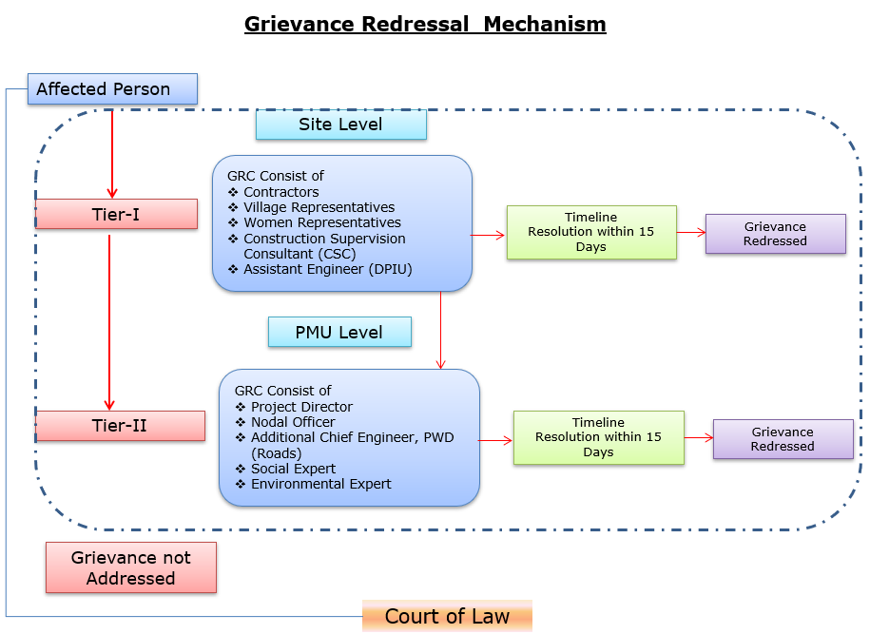
Grievances submit debak baksa contact information-rang baksa debak.
Baksa debak pora detail nai explanation | Baksa debak pora contact information, phone number, email, nai address
Company: | PWD, Meghalaya
To: | Chief Engineer-cum-Nodal officer
Address: | HV9P+GFJ, Lachumiere, Shillong, Meghalaya 793001
E-mail: | esmlcip@gmail.com
Website: | http://megpwd.gov.in/contacts.html
Telephone: | Tel: 0364-3572466
Fax: | -

Project-rang governance aro overall institutional structure-rang baksa debak.
Ka kam-rangkam ka dakgipa donggipa jylla Government of Meghalaya (GoM)-ni donggipa institutional architecture baksa meligrikgen, aro Sixth Schedule-ni niyam rangsani, janggi jatni hokrang (tribal autonomy)-ko dakchakgen.
MIDFC, je project-ni sabsi kamrangko dakchakgipa aro taka-paisani bynta nanggipa ong∙a, ua project-ni holder aro lead implementing agency ong∙gen.
MPWD-de civil works (rasta, bridge aro ropeway)-rangko dakchakgen, aro Department of Agriculture (DoA) aro MBMA-rangde agrologistics aro community components-rangko kam ka∙gen.
MIDFC-PMU-ni rangko project management aro coordination-rangko dakchakgen, World Bank-ni procedure-ko experience napha officers-ni through.
PMC, je team-ni expert aro consultant-rangni Team Leader-ni ong∙a dakchakgen, project activities-rangko technical support-ka∙gen, je implementing agencies-ni skill set-ni napha dang∙a.
CSC-ni construction supervision-ka∙gen.
PMC/CSC aro information collect aro document-ka∙gen-rangni aid ka∙gen.
Project implementation structure-ko figure-ni dang∙a dakchak:
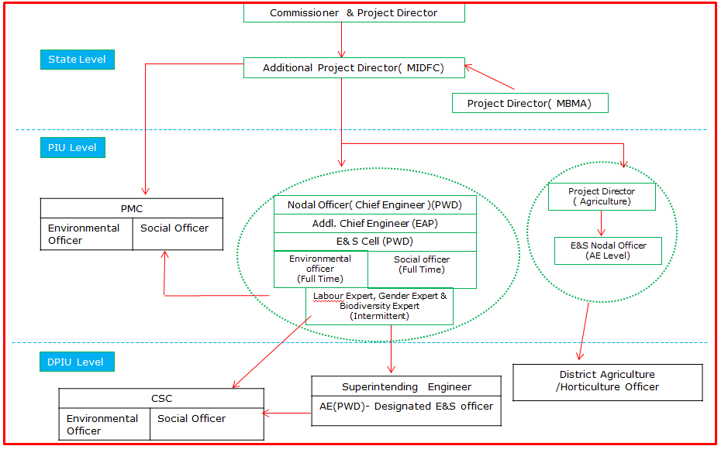
Figure: Project Kam-rangkam Organogram
Khutcha
ESIA-ni phayrang dakchakni phangni ni nangni gital:
- Proposed projectko traffic flow kema ka∙a aro motor vehicle aro pedestrianrangna safe aro smooth mobility on∙gen. Proposed road improvement-ni ja∙mano road-ni asakgipa section-ona market jakkale somoyko 1 hour-ona 30 minut jakkale tang∙manaha. Project East aro Garo Hills district-o trade aro commercial activity (public transport-ba) gima encourage ka∙na gital ong∙a.
- Environmental aro social impact assessment World Bank ESF aro National & State regulation an∙tangtangna miksongaha. Pilak potential impacts pre-construction, construction, aro operation phase-rango identify ong∙aha.
- Ronggitchamni road State Highway ong∙a, aro elevation 150 m (AMSL) ato low-lying eastern area-rango 1,400 metre southwestern highland-rang jakkale ong∙a. 14th July 2022-ni EIA Notification an∙chingko miksonga je, Line of Control ka∙dongan international border-ni 100 km range defense ka∙dongan strategic importance-ni highway projectrang prior environmental clearance ong∙ja, Standard Operating Procedure (SOP) an∙tangtangni jakrango comply ka∙gimin. Ia an∙tango, proposed projecto environmental clearance namgija.
- Proposed project alignment Wildlife Sanctuary/National Park/Biosphere Reserve/Tiger Reserve-rango parik ja∙mano.
- Project site-ni 0.5 km range ASI Protected monuments dongja.
- Road-ni pilak boko existing Right of Way (RoW)-o jak 36 tree dongenga. Tree felling-ni ecological impact katchakna, compensatory afforestation applicable environmental regulation aro guideline an∙tangtangna miksongna gita ong∙gen.
- Project roado corridor range construction kamko man∙gipa, cultural importance sako community center, church, school, jemangan, aro Project-Affected Persons (PAPs)-na access-related issues ong∙gimin gita jak environmental aro social impact ong∙na man∙gen.
- Stakeholder Consultations manderangni proposed project gimin kattarangko assess ka∙na dakaha. Consultations-ni outcome manderang projectko dakaha maina ia ronggitchamni road condition aro connectivityko improve ka∙gen. Indiba, uamang road safety measures; road furniture (streetlights, signage, speed breaker, jemangan) aro uamangni assets rong∙anina proper compensation-ni kattarangko daka.
- Worker aro local community-ni occupational health aro safety measures Labour Management Plan (LMP) preparation aro implementation ka∙anina World Bank-ni Environmental and Social Standard ESS2 (Labour aro Working Conditions) an∙tangtangna comply ka∙na gita man∙gen.
- Ia mitigationsko construction aro operation ja∙mano environmental aro social monitoring program dakna gita katchakaha je, pilak measures implementation ong∙a aro environmental aro social condition an∙tangtangna stipulate ka∙a protect ka∙a. Ia on-site aro off-site observation, document check, worker aro beneficiary-rangna interview, aro remedial action namgipa kattarang contractor MPWD-na report ka∙a.
- ESMP bidding document-o contractual clause an∙tangtang-ba safeguard ka∙anina environment aro social impact project construction aro operation (maintenance period) ja∙mano ong∙gimin. ESMP bidding document-o dakboaha.
- Overall project level aro construction stage level Grievance Redress Mechanism (GRM) affect gipa partyrangna feedback, suggestion aro complaint, jemangan, receive ka∙na aro construction stage aro operation stage ja∙mano address ka∙na ong∙gen.
- Prepared ESMP Contractor aro MPWD-na Environmental aro Social impacts katchakna aro proposed project environmentally sound execution ka∙na guide ka∙gen.
- Updated ESMP-ni kopi construction period ja∙mano on-site chakatako ra∙na gita. World Bank policy requirement an∙tangtangni jakrango, prepared safeguard documents World Bank website-o disclose ong∙gen.

Capacity building and training

Environmental aro Social Management Plan (ESMP)-ni implementation aro monitoring-ni capability-ni improve-ka∙gen, structured training programs-ni contractor aro project personnel-ni gi sabsi conduct-ka∙gen dakchakni recommend-ka∙gen.

Training-ni regulatory requirements-ni compliance ensure-ka∙gen, awareness improve-ka∙gen aro environmental aro social (E&S) risks-ni manage-ka∙gen competence build-ka∙gen.

On-Boarding Phase
a. Induction Training
- Sabsi personnel-ni work start-ka∙gen ni mandatory.
- Contractor-ni Environmental aro Social Management Plan (C-ESMP), relevant national aro international Environmental, Social, Health aro Safety (ESHS) regulations aro good practices-ni cover-ka∙gen.
b. Specialized Training
- Personnel-ni specific roles-ni (e.g., environmental officer, safety officer, waste management supervisor) assigned-ka∙gen tailored training.
- Mobilization stage-ni deliver-ka∙gen, assigned responsibilities-ni readiness ensure-ka∙gen.

Implementation Phase
- Ongoing Toolbox Talks:
Daily aro weekly conduct-ka∙gen, evolving risks address-ka∙gen, safety practices reinforce-ka∙gen aro workers-ni continuous awareness maintain-ka∙gen.
- Supplemental Training:
Incident-hako pare or new risks identify-hako pare provide-ka∙gen. Recurrence prevent-ka∙gen aro workforce-ni new safety/environmental requirements-ni updated rakha∙gen.
- Routine Quarterly Training:
- Contractor-ni every three months organize-ka∙gen:
- E&S compliance status aro progress review-ka∙gen.
- Previous quarter-ni lessons learned share-ka∙gen.
- Identified gaps aro challenges address-ka∙gen action plans develop-ka∙gen.
- Sub-project E&S objectives-ni alignment ensure-ka∙gen aro continuous improvement promote-ka∙gen.

Outcomes of the stakeholders

Songsak-Mendipathar Road-ni FPIC process community engagementko gima strong ka∙a aro final consent ong∙aha.
Dandakol, Thapa Darenchi, aro Koksi Nengsat village-rango FPIC-1 meeting 5 September 2025-o dakaha. Ia meetingrango key issues road widening aro curve improvement-ni gimin land requirement, fair compensation gimin kattarang, aro residential area-o protective work aro safety feature-ni request ong∙aha. Project team road intermediate lane (5.5m) ong∙gen ine chakchikaaha, land acquisition minimal ong∙gen ine, compensation legal framework an∙tangtangna man∙gen ine assure ka∙aha, aro safety measurerangko include ka∙na aro detailed Environmental aro Social Impact Assessment dakna project planning aro mitigation guide ka∙na commit ka∙aha.
Dandakol, Thapa Darenchi, Koksi Nengsat, aro Samin Songkama village-rango 25 September aro 7 October 2025 jakrango FPIC-2 meetingrang dakaha. Ia meetingrango community retaining wall, drain, toilet, aro bus waiting shed jemangan additional infrastructure-ni request; past construction quality gimin kattarang; contract award, DPR access, aro dismantled structure-ni compensation gimin kattarang daka. Mitigation gita, project team feasible suggestionrangko FPIC-3 review-na project design-o incorporate ka∙gen ine assure ka∙aha, compensation established policy framework an∙tangtangna man∙gen ine chakchikaaha, ongoing complaintrangna GRM ka∙na encourage ka∙aha, aro project success ensure ka∙na community cooperation-ni namani ko me∙chapa ka∙aha.

October 2025-o Thapa Derenchi, Dandakol, Koksi Nengsat, Darekkol, aro Samsi Songkama village-rango FPIC-3 meetingrang dakaha. Ia meetingrango written consent namgipa land acquisition, structure-rangna environmental aro social impact, past construction quality gimin bikram, aro compensation procedure gimin kattarang daka. Mitigation gita, project team land requirement detailrangko affect gipa community-rangna verify aro share ka∙na consent on∙na commit ka∙aha, compensation Resettlement Policy Framework an∙tangtangna strictly man∙gen ine assure ka∙aha, aro ongoing feedback aro quality assurancena Grievance Redress Mechanism ka∙ani ko me∙chapa ka∙aha.

9 December 2025-o Koksi Nengsat, Samin Songkama, Dandakol, aro Thapa Darenchi village-rango FPIC-4 meetingrang dakaha. Ia meetingrango community boundary wall, toilet, aro bus waiting shed jemangan protective infrastructure-ni request; past poor construction quality gimin kattarang; aro work commencement aro DPR jemangan project document access gimin kattarang daka. Mitigation gita, project team request gipa facilitiesrang approve ong∙a ka∙donggipa ong∙a ine confirm ka∙aha, compensation Resettlement Policy Framework an∙tangtangna strictly man∙gen ine assure ka∙aha, aro February-o work kamna nokgipa timeline on∙aha.

Resettlement Action Plan (RAP)

Resettlement Policy Framework (RPF)-ni gi meligrik, project-ni social impacts avoid aro minimize-ka∙gen measures adopt-ka∙gen, careful design aro existing RoW-ni use-ka∙gen.
Continuous consultations conduct-ka∙gen aro functional GRM-ni ensure-ka∙gen, concerns-ni timely resolve-ka∙gen. Sabsi entitlements RPF-ni meligrik provide-ka∙gen.
Road section-ni identified impacts-ko basis-ni, detailed site-specific Resettlement Action Plan (RAP) prepare-ka∙gen, ha·ni final entitlements, mitigation measures, implementation arrangements aro monitoring framework outline-ka∙gen, aro civil works start-hako pare implement-ka∙gen.

